AUSTRALIAN COUNCIL FOR THE DEFENCE OF GOVERNMENT SCHOOLS

PRESS RELEASE 533#

23 November 2013

PRIVATE SCHOOLS PROTECTING THEIR BRAND IS NO

BLUE PRINT FOR EDUCATING A NATION’S CHILDREN

Fees set to soar at Victoria's elite private schools: As private schools compete against each other for the middle class dollar, Victorian State school children go begging. Market competition private school style is no recipe for educating a nation.

Konrad Marshall, Craig Butt, and Benjamin Preiss of The Age (November 17, 2013) reported Melbourne University economics Associate Professor Joe Hirschberg’s as forecasting that annual school fees at elite independent schools will reach $30,000 on average by 2016. The following table. The table reproduced from The Age below indicates increases within the next year.
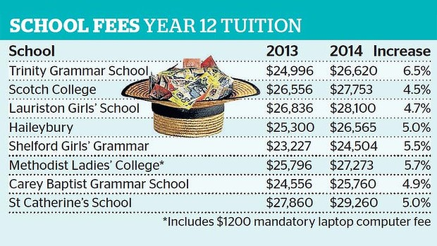
Average growth rate of private school fees in the senior years had outstripped rises in medical and hospital services. The description of Trinity College Melbourne’s school new $17 million multi-level library and classroom complex, with angular steel beams and lengths of cable upon which fresh green creepers will eventually cascade, crawling up from the rooftop garden indicates the degree to which these schools will go to protect their ‘market share’ and marketing ‘brand’. But who wants or can afford this educational ‘brand’?
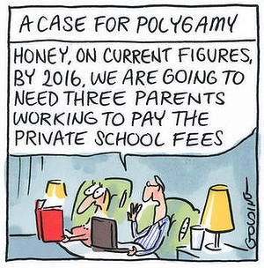
Illustration: Matt Golding, The Age 17.11.2013

Sensible parents are doing their sums, realising that not even a double income, one child family can provide education for that single child. They are moving house to find a good State secondary school.
But there is a problem. State secondary schools are no longer being built in Australia and schools like Sandringham Secondary College are being run down and out.
Australian citizens need to realise that the Denominational system never has, never intends to and never will be able to do the job of educating Australian children.
As the 1844 Commission of Enquiry into the Denominational System in NSW discovered:
The first great objection to the denominational system is its expense; the number of schools in a given locality ought to depend on the number of children requiring instruction, which that locality contains. To admit any other principle is to depart from those maxims of wholesome economy, upon which public money shold always be administered. It appears to your Committee impossible not to see, that the very essence of a denominational system, is to leave the majority uneducated, in order thoroughly to imbue the minority with peculiar tenets.
LISTEN TO THE DOGS PROGRAM
3 CR : 855 ON THE AM DIAL
12 NOON SATURDAYS
ALSO ON PODCAST

